Density Based Traffic Signal Controller

Muhammad Sanaullah Kayani

Gulfraz



**July 17, 2020**

Department of Computer Science

COMSATS University Islamabad

Attock Campus

|  |  |  |  |  |
| --- | --- | --- | --- | --- |
| **PROJECT ID** |  |  | **NUMBER OF MEMBERS** | 2 |

|  |  |
| --- | --- |
| **TITLE** | Density based traffic signal controller |

|  |  |
| --- | --- |
| **SUPERVISOR NAME** | Mr. Rehan Tariq |

|  |  |  |
| --- | --- | --- |
| **MEMBER NAME** | **REG. NO.** | **EMAIL ADDRESS** |
| Muhammad Sanaullah Kayani | Fa16-BCS-035 | muhammadsanaullahkayani@gmail.com |
| Gulfraz | FA16-BCS-009 | Khurram.gulfaraz904@gmail.com |
|  |  |  |
|  |  |  |

|  |  |
| --- | --- |
|  |  |

**MEMBERS’ SIGNATURES**

Supervisor’s Signature

**DECLARATION**

We hereby declare that this software, neither whole nor as a part has been copied out from any source. It is further declared that we have developed this software and accompanied report entirely on the basis of our personal efforts. If any part of this project is proved to be copied out from any source or found to be reproduction of some other. We will stand by the consequences. No Portion of the work presented has been submitted of any application for any other degree or qualification of this or any other university or institute of learning.

**MEMBERS’**-**SIGNATURES**

**CERTIFICATE OF APPROVAL**

It is to certify that the final year project of BS (CS) “Density Based Traffic Signal Controller” was developed by Muhammad Sanaullah Kayani (CIIT/Fa16-BCS-035) and Gulfraz (CIIT/FA16-BCS-009) under the supervision of “Rehan Tariq” and that in their opinion; it is fully adequate, in scope and quality for the degree of Bachelors of Science in Computer Sciences.

---------------------------------------

Supervisor

---------------------------------------

External Examiner

---------------------------------------

Head of Department

(Department of Computer Science)

**Acknowledgement**

For the sake of **ALLAH**, the most kind and generally forgiving.

We might want to thank our family who kept support us in every one of the circumstances, both monetarily and ethically.

We might likewise want to say thanks to **Mr. Rehan Tariq** for his direction and urging us to buckle down and shrewd. We have discovered him extremely help full while talking about the streamlining issue in this project. His basic remarks on our work have positively made us consider new thoughts and systems in the field of improvement and programming reenactment.

Abstract

In present life, we have to face many problem related to traffics that cause congestion especially at road intersections, and with the rapid increase in number of automobile this is becoming most serious issue in our daily life. This is because the terminology that are being used in traffic signals is not so efficient due to the large delay on each junction. The current system is based on fixed logic irrespective of the density of traffic on each lane. To make better use of traffic signals, we are going to make density base traffic signal system. In this system, we use IR sensor to measure the traffic density. We have to mount two or three IR sensors for each road, the distance between these sensors will depend on nature of vehicle on a particular junction. These sensors will sense the vehicle on that particular road. All these sensors are interfaced to the PIC microcontroller. On basis of these sensors, controller detects the vehicle and dynamically set up the time delay of signals. Our proposed system will also try to resolve the emergency vehicle issue. In this we will use IR Receiver technology to give priority to the emergency vehicle side.

**Table of Contents**

1. Introduction 2

1.1 Brief 2

1.2 Relevance to Course Module 2

1.2.1 Arduino Atmega2560 2

1.2.2 IR Sensor 3

1.2.3 ESP8266 Wemos Wi-Fi Module 3

1.3 Project Background 4

1.4 Literature Review 4

1.4.1 Analysis from Literature Review 5

1.5 Methodology and Software Life Cycle 5

1.5.1 Incremental Model 5

1.5.2 Rationale behind Selected Methodology 6

1.6 Advantages/Benefits of Proposed System 7

1.7 System Limitations/Constraint 7

2 Problem Definition 9

2.1 Problem Definition 9

2.2 Deliverable and Development Requirements 9

2.2.1 Hardware Requirement 9

2.2.2 Software Requirement 10

2.3 Current System 11

3 Requirement Analysis 13

3.1 Use Case Diagrams 13

3.2 Detailed Use Case 13

3.2.1 Admin Use Case Diagram 13

3.2.2 Traffic Controller Use Case Diagram 16

3.2.3 Use Case Diagram for Emergency Vehicle Driver 19

3.3 Functional Requirements 20

3.3.1 Functional requirements of our system are: 21

3.4 Non Functional Requirements 22

3.4.1 Non Functional Requirements of our system are 22

4 Design & Architecture 24

4.1 Block Diagram 24

4.2 Activity Diagram Description 24

4.2.1 Admin Activity Diagram 25

4.2.2 Employee (Traffic Controller) Activity Diagram 26

4.2.3 Hardware Activity Diagram 27

4.3 Sequence Diagram 28

4.3.1 Sequence Diagram for Admin 28

4.3.2 Sequence Diagram for Traffic Control System 29

4.3.3 Sequence Diagram for Emergency Driver 30

4.4 Data Flow Diagram 31

4.4.1 DFD Level 0 31

4.4.2 DFD Level 1 32

4.5 Entity Relationship Diagram ERD 33

4.5.1 Description 33

5 Implementation 35

5.1 Algorithm 35

5.2 External API 36

5.2.1 Google Map API 36

5.3 User Interface 37

5.3.1 Website 37

5.3.2 Android 41

5.3.3 Configuration of Arduino & Wi-Fi 43

5.3.4 System Integration 44

6 Testing & Evaluation 46

6.1 Manual Testing 46

6.1.1 System Testing 46

6.1.2 Unit Testing 46

6.1.3 Functional Testing 46

6.1.4 Integrated Testing 48

6.2 Automated Testing 49

*6.2.1* *Automated testing tool* 49

7 Conclusion and Future Work 51

7.1 Conclusion 51

7.2 Future Work 51

8 References 51

**Table of Figures**

Figure 1.1:IR Sensor 3

Figure 3.1: IR Sensor Work 3

Figure 3.3: ESP8266 Wi-Fi module. 3

Figure 4.1: Incremental Model 5

Figure 3.2: Admin Use Case 13

Figure 3.3: Traffic Controller Use Case. 16

Figure 3.3: Emergency driver Use Case. 19

Figure 4.1: Block Diagram 24

Figure 4.2: Admin Activity Diagram 25

Figure 4.3: Traffic Controller Activity Diagram 26

Figure 4.4: Hardware Activity Diagram 27

Figure 4.5: Sequence Diagram for admin 28

Figure 4.6: Sequence Diagram for Traffic Control System 29

Figure 4.7: Sequence Diagram for Emergency Vehicle Driver 30

Figure 4.8: Data Flow Diagram Level (0) 31

Figure 4.9: Data Flow Diagram Level (1) 32

Figure 4.9: ERD 33

Figure 5.1: Google Map API 36

Figure 5.2: Website login 37

Figure 5.3: Admin Dashboard 38

Figure 5.5: Monitoring Room Graphical Representation 38

Figure 5.6: Monitoring Room Tabular Representation 39

Figure 5.7: Traffic controller’s record 39

Figure 5.8: Register Employee 40

Figure 5.9: Emergency Map 41

Figure 5.10: Emergency Login 41

Figure 5.11: Emergency Registration 42

Figure 5.12: Emergency Dashboard 42

Figure 5.13: Emergency Location 43

Figure 5.14: Configuration of Arduino & Wi-Fi 43

Figure 5.15: System Integration 44

**List of Tables**

Table 2.1: Deliverables and Development Requirements 10

Table 2.2: Existing System 11

Table 3.1: Functional Requirements 21

Table 3.2: Non-Functional Requirements 22

Table 5.1:External APIs 36

Table 6.1.3.1: Test case for admin 46

Table 6.1.3.1: Test case for traffic controller 47

Table 6.1.4.1: Integrated test no 1 48

Table 6.1.4.2: Integrated test no 2 48

Table 6.1.4.3: Integrated test no 3 48

Table 6.2.1: Automated Testing 49

Chapter 1

Introduction

# **Introduction**

## **Brief**

Traffic signals are mainly developing to ensure the correct flow of vehicles and provide an opportunity for automobile and pedestrians to cross a junction and also help to reduce the congestion between the traffic. In Pakistan, we have to face many problem related to traffics that cause congestion especially at road intersections, which is becoming most serious issue in our daily life. This means that the current technology that are being use in signal area is not so efficient due to fixed logic irrespective of the density of traffic on each lane. With the rapid growth of vehicle in our cities, there is a need of traffic management scheme that use different modern technique to overcome the collision between traffic and to reduce the congestion on road in an efficient way.

To make better use of traffic signals, we are going to make a signal based on vehicles density by using **PIC microcontrollers** (Programmable Interface Controllers), IR sensors and other more sensor to make advancement in traffic signals. The highest benefit of this system is that it will reduce the waiting time of vehicles. Manyof thepeople in our country violate the traffic rule just because to reach their destination in time, that cause accident and create issue for other. In this system, we will also give priority for the ambulance to save life.

Keywords: Arduino Atmega2560, IR sensor, IR Receiver, ESP8266 Wi-Fi Module, Website.

## **Relevance to Course Module**

### **Arduino Atmega2560**

A microcontroller board atmega2560 architecture is based on RISC, and is designed for more complex projects. It has high-performance with 256KB of flash memory, 4KB EEPROM, 8KB SRAM, 8 General Purpose Working Registers, 13 analog and 54 digital input/output pins. And it is easily programmable, just by connecting with a computer/laptop trough USB port, or you can give it power through simple battery. Moreover, it’s operate between a 4.5 and 5 volts and can achieves 16 MIPS throughput at 16 MHz. The purpose to using Atmegea2560 in this project is their large number of input capacity. To manage the large number multiple wire in Atmega2560 is very easy as compare to other modules and it’s compatible with mostly all the shields that are designed for UNO.

### **IR Sensor**

IR sensor is a sensor work on infrared radiation, detects specific radiations that fall on it. It is use to detect the obstacles or motion of object, and is one of the most common application in real time.

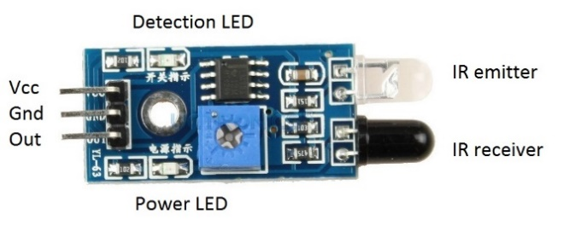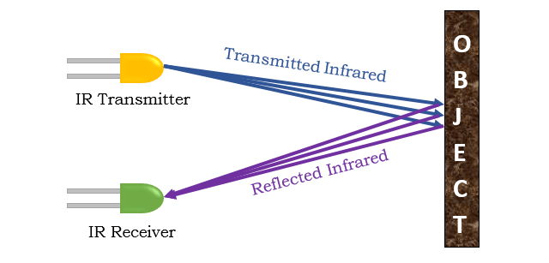

**Figure 1.1 IR Sensor Figure 1.2 IR Sensor work**

#### **IR transmitter**

IR sensor emit the infrared light through IR LED that cannot be visible to human eyes. Infrared LEDs have an approximate angle of about 20 to 60 degrees and has a range of few centimeters to a few feet, depending on the type and manufacturer of the infrared emitter. Some high quality IR sensor have a range in kilometer.

#### **IR Receiver**

IR receiver receives the light through photodiode that is emitted by IR transmitter. IR LED escape the light that smash the solid surface and reflects back to the IR receiver (photodiode). It give output High when this observe no object place in front of it, and LOW when recognize any object.

### **ESP8266 Wemos Wi-Fi Module**

ESP8266 is a small module contain TCP/IP protocol that allow microcontroller to connect to the Wi-Fi using UART (Serial) or Wire connection. It is sophisticated module that solves our inconveniences problem and it can be easily configure with programing device by using USB cable. By using this module, we can easily control our web page or android app.

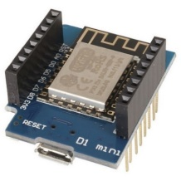

**Figure 1.4 ESP8266 Wi-Fi module**

## **Project Background**

Like previously discussed in introduction density base traffic signal is an automatic system that will provide efficient flow of traffic signal, based on vehicle density. We will try to resolve all the issue that cause congestion at signal area and provide ease for drivers. In this proposed system, we will use using PIC microcontroller’s atmega2560, IR sensors and RF technology. The IR sensor will use to check the density of each lane and RF module will try to sense the emergency vehicle. The proposed system check the density of traffic on each side roundabout and estimate the time according to the density, so the system will allot more time to the denser side and less time to less denser side base on traffic. And the signal will work either in clockwise or anti-clockwise direction which will be predefined.

## **Literature Review**

The traffic design on Pakistan’s roads is diverse in the living world. The ratio of accident is also increasing in numbers due to the vast quantity of vehicle’s rising every year. In Pakistan round about 20 people out of 100,000 loses life in road accident annually. Due to this rate of accident in Pakistan, Pakistan will get number 67 in the world for a huge percentage of road traffic accident.

In his thesis, K.M. Yousef introduced an adaptive traffic control system that is based on a transport infrastructure and uses a wireless sensor network to control traffic flow K.M Yousef also introduced intelligent traffic controllers to handle transportation infrastructure systems carried by wireless sensor networks (WSN).It uses wireless transmission to sense traffic and change traffic lights. It only makes the existing traffic light system easy to install, but it is not for safety purposes.

P. Sinhmar has introduced in his research paper to decrease the number of traffic congestion using IR sensor and microcontroller. The infrared transmitter and receiver will detect the number of vehicles that stands on the road and base on this collected information, the microcontroller will decide to change the traffic signal delay. Such a system helps to obtain accurate statistics and helps design better traffic lights. A number of advance transport system technologies were developed around the globe to provide ease of transportation for the people. Such type of system includes CCTV system, Bluetooth detection, GPS based traffic system and sensing technologies.

### **Analysis from Literature Review**

After study the different research paper about intelligence traffic signal and look at the condition of Pakistan traffic. A multiple of ideas are generated in our mind to resolve the issue that occurs due to congestion of traffic at signal area. P. Sinhmar introduced a very unique idea for the solution of this issue, so in our final year project we will make a system that will be based on different sensor attached with microcontroller to take advancement in current traffic signal working. The proposed system will help to reduce the congestion on signal area and to give priority to the emergency vehicle side. Also in our proposed system, the traffic controller can easily operate the signal through monitor screen. This will resolve the half of the traffic issue in our country and give ease to the drivers and pedestrians.

## **Methodology and Software Life Cycle**

### **Incremental Model**

For developing any sort of software we must need a method to follow it and produce a productive software that’s why for our FYP we uses the methodology known as Incremental Methodology.

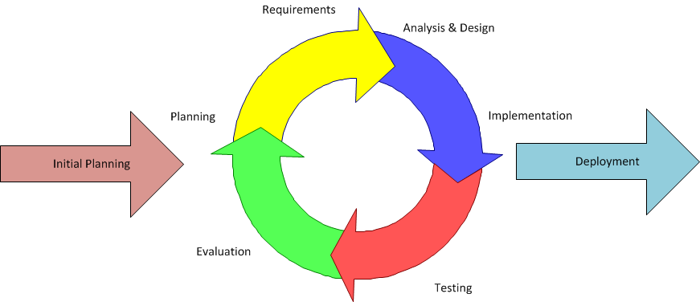

**Figure 1.5 Incremental Model**

This figure illustrates the flow of this model that consist of following phases

* Initial Planning
* Implementation
* Deployment
* Testing
* Evaluation

After that, all these above activities will be done for second increment and so on until the completion of increments.

#### **Planning of First Increment**

In this phase we have planned for our first increment that what we have to implement in first increment that is web development increment.

#### **Implementation of first Increment**

We have implemented the main page for our web GUI.

#### **Deployment of first Increment**

We have deployed the web GUI.

#### **Testing of first Increment**

We have tested our web GUI that whether it is working properly or not.

#### **Evaluation of first Increment**

We have evaluated that whether the whole system meets the requirements or not.

### **Rationale behind Selected Methodology**

We use the incremental model for the following reason

* Division of project in multiple standalone module.
* Testing is done after every increment in model.
* We can improve the system performance after every increment.

## **Advantages/Benefits of Proposed System**

The proposed system has multiple advantages our previous fix base traffic control management system.

* Fully automatic.
* The design circuit is low in cost and the circuit is well maintained.
* We can reduce a lot of futile time.
* We can avoid excessive amount of traffic congestion and lead to public problems.

## **System Limitations/Constraint**

## IR sensors can sometimes absorb normal light. As a result, the transportation system works in an improper manner.

* We must arrange the infrared sensors in an accurate manner or they may not be able to detect the traffic density.
* The implementation cost is quite high, but it is most suitable for busy roads in Pakistan.

Chapter 2

Problem Definition

# **Problem Definition**

## **Problem Definition**

As we know, now a days Pakistan is facing very critical situation regarding traffic congestion on signals due to the constant movement of people from rural to urban areas. Large numbers of vehicles infrastructure, inadequate and irrational distribution of development projects are the main cause of congestion at the junction point. The main cause of traffic congestion is the massive number of vehicles caused by economic development and population. Problem of traffic is also increasing because of the growth of human and increase in vehicle rate. The vast amount of people migrate from rural to urban area because of the less number of facilities are provided in rural area. Due to this, a large number of people gather in a specific place and become a reason of congestion. The traffic in that area demand for a large road but in some place due to the narrow structure, traffic stuck there and cause congestion. Traffic jams can cause frustration to drivers and cause road rage. Urban traffic regulation is one of the most challenging issues today. To avoid heavy traffic, Traffic Sign Recognition used different techniques like regulate traffic signs that warn the drivers to prohibit certain actions. This is not enough to resolve the traffic congestion. The main reason is that the terminology that is using in the signal area is not so efficient either this one is based on fixed knowledge or manual, both are not working well. Although there are no vehicles at certain side, but the current traffic signals will glow a green light for given fixed time that is pre-defined. This is time waste process, utmost annoying for our public and due to this, other side vehicles have to wait for some time until the process complete it cycle. To overcome this issue, we proposed a system that control the traffic at road intersections base on their density and also to give priority to the emergency vehicle.

## **Deliverable and Development Requirements**

A complete project report which includes Software Requirement Specification, Software Design Specification and other major tasks performed. In our project, both hardware and software are required to operate.

### **Hardware Requirement**

* Arduino Mega 2560
* Wemos Wi-Fi module
* LEDS
* Wires
* IR SENSOR
* IR Receiver

### **Software Requirement**

**Table 2.1: Deliverables and Development Requirements**

|  |  |  |
| --- | --- | --- |
| **Tools** | **Version** | **Rationale** |
| Arduino | 1.8.10.0 | IDE |
| Bracket | - | - |
| Android Studio | 3.6.1 | IDE |
| PHP my admin | - | DBMS |
| MS Word | 2016 | Documentation |
| MS Power Point | 2016 | Presentation |
| Visio | 12.3.2 | Diagrams |
| **Technology** | **Version** | **Rationale** |
| C++ | - | Programming Language |
| Bootstrap, HTML, XML, CSS | - | Interface |
| PHP | - | Programming Language |
| Java | - | Programming Language |
| JavaScript | - | Programming Language |

## **Current System**

Traffic pattern on Pakistan roads is mostly same in nature. The 3 LEDs lights are using to control the traffic signal that are Red, Green and Yellow. Each LED has its own function, Red LED indicates that stop sign for driver, Yellow LED is to alert the driver that signals are going to change and green LED mean the signal opens. The color used in traffic signals light are almost same in all over the world but the technology that are use behind are vary from country to country. In Pakistan, existing systems of traffic signals are either automated or manual systems. In automatic mode, fixed logic is used behind the signals irrespective of the density of traffic on each lane, each lane has given a fix time delay of 45 second that does not vary either the traffic has low density, medium or high density. Although there are no vehicles at certain side, but the current traffic signals will glow a green light for given fixed time that is pre-defined. The other oldest traffic signal method that are used in Pakistan is controlled by traffic controller through his hand gesture. This method require more attention of controller and take human effort more. A little mistake of traffic controller may will become a lethal for human being. The existing system of traffic has no possible solution for emergency vehicle that were used to pass the emergency.

**Table 2.2: Existing System**

|  |  |  |
| --- | --- | --- |
| **Existing**  **Traffic**  **signals** | **Automatic Operate** | **Manual Operate** |
| * Fix time delay. * Signals flow while there is no traffic on road. * Emergency vehicle problem does not handle in existing signals. | * Traffic controller control traffic through his hand gesture * Take more human effort. * A human become active 24 hour. * Cannot negotiate a small mistake of traffic controller. They may become a more dangerous for human health. |

Chapter 3

Requirement Analysis

# **Requirement Analysis**

## **Use Case Diagrams**

The use case shows the full schematic view of our system and how actors would interact with each other and how they will interact with the system. It is a graphical depiction of the connections between the elements of the system. A use case is a procedure used in exploring the system to simplify and organize the system necessities.

* Admin UCD
* Employee UCD (for traffic controller)
* Emergency driver UCD

## **Detailed Use Case**

### **Admin Use Case Diagram**

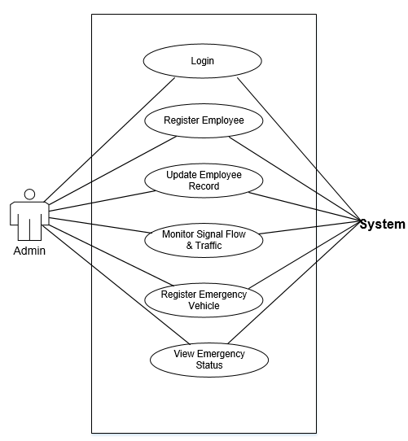

**Figure 3.1 Admin Use Case**

Figure 3.1validates the use case of an administrator where he/she can access to the application. The administrator can entrance to their home page by Login to the admin panel, and can analyze flow of traffic signal, register new employee, update employee record and can view all employee information.

#### **Use case ID: UC-1.1**

**Use-Case Name**: Login

**Actor**: Admin

**Description**: Admin shall be able to login to the admin panel.

**Pre-condition**: Admin should be given a username and password to login to the admin panel.

**Post-condition**: Admin shall be able to login to the panel easily.

#### **Use case ID: UC-1.2**

**Use-Case Name**: Register Employee

**Actor**: admin

**Description**: Admin will register the new employee into our system.

**Pre-condition**: Admin should have to give accurate and relevant information which is needed for registration.

**Post-condition**: Admin will successfully registered new employee.

#### **Use case ID: UC-1.3**

**Use-Case Name**: Update Employee Record

**Actor**: admin

**Description**: Admin will be able to update the employee record.

**Pre-condition**: Admin should have to give accurate and relevant information where he want to update record.

**Post-condition**: Admin will successfully update the employee record.

#### **Use case ID: UC-1.4**

**Use-Case Name**: Monitor Signal flow & Traffic

**Actor**: admin

**Description**: Admin will be able to monitor the traffic signal through screen.

**Pre-condition**: Admin will perform the specific action that are require for monitoring.

**Post-condition**: Admin will be able to view the monitoring screen and traffic flow.

#### **Use case ID: UC-1.5**

**Use-Case Name**: Register Emergency Vehicle

**Actor**: admin

**Description**: Admin will register the new emergency vehicle into our system.

**Pre-condition**: Admin should have to give accurate and relevant information which is needed for registration.

**Post-condition**: Admin will successfully registered new Vehicle.

#### **Use case ID: UC-1.6**

**Use-Case Name**: View Emergency Status

**Actor**: admin

**Description**: Admin will be able to view the emergency vehicle status in case of any emergency.

**Pre-condition**: Admin will perform the specific action that are require to view emergency status.

**Post-condition**: Admin will be able to view the current emergency location status.

### **Traffic Controller Use Case Diagram**

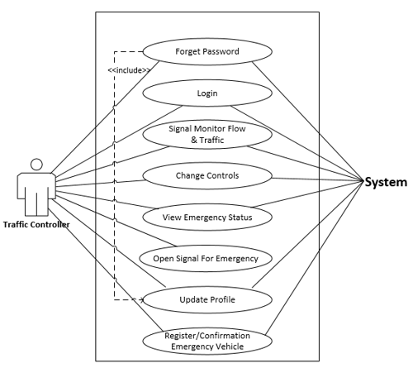

**Figure 3.1 Traffic Controller Use Case**

#### **Use case ID: UC-2.1**

**Use-Case Name**: Forget Password

**Actor**: Traffic Controller

**Description**: Traffic controller will forget his password into our system, if he/she forget.

**Pre-condition**: Traffic controller should have to give accurate and relevant information which is needed for forget password.

**Post-condition**: Traffic controller will successfully forget his/her password.

#### **Use case ID: UC-2.2**

**Use-Case Name**: Login

**Actor**: Traffic Controller

**Description**: Traffic controller shall be able to login to the dashboard.

**Pre-condition**: Traffic controller should be given a CNIC and password to login to the admin panel.

**Post-condition**: Traffic controller shall be able to login to the dashboard easily.

#### **Use case ID: UC-2.3**

**Use-Case Name**: Monitor Signal flow & Traffic

**Actor**: Traffic controller

**Description**: Traffic controller will be able to monitor the traffic signal through screen.

**Pre-condition**: Traffic controller will perform the specific action that are require for monitoring.

**Post-condition**: Traffic controller will be able to view the monitoring screen and traffic flow.

#### **Use case ID: UC-2.4**

**Use-Case Name**: Change Control

**Actor**: Traffic controller

**Description**: Traffic controller will be able to switch the traffic signal from density mode into fix time delay mode. It can Turn ON or turn OFF the traffic Signal.

**Pre-condition**: Traffic controller will perform the specific action that are require for switching the traffic signal mode and to Switch ON/OFF.

**Post-condition**: Traffic controller will successfully switch the traffic signal working from density to fix or ON to OFF or vice versa.

#### **Use case ID: UC-2.5**

**Use-Case Name**: View Emergency Status

**Actor**: Traffic controller

**Description**: Traffic controller will be able to view the emergency vehicle status in case of any emergency.

**Pre-condition**: Traffic controller will perform the specific action that are require to view emergency status.

**Post-condition**: Traffic controller will be able to view the current emergency location status.

#### **Use case ID: UC-2.6**

**Use-Case Name**: Open Signal for Emergency

**Actor**: Traffic controller

**Description**: Traffic controller will be able to open the specific side traffic signal for emergency vehicle.

**Pre-condition**: Traffic controller will perform the specific action that are require to open traffic signal.

**Post-condition**: Traffic controller will successfully open the specific side traffic signal.

#### **Use case ID: UC-1.7**

**Use-Case Name**: Update Profile

**Actor**: Traffic controller

**Description**: Traffic controller will be able to update his/her profile.

**Pre-condition**: Traffic controller should have to give accurate and relevant information where he want to update profile.

**Post-condition**: Traffic controller will successfully update his/her profile.

#### **Use case ID: UC-1.8**

**Use-Case Name**: Registration/Confirmation Emergency Vehicle

**Actor**: Traffic controller

**Description**: Traffic controller will register the new emergency vehicle, or it can confirmation/verify the emergency vehicle into our system.

**Pre-condition**: Traffic controller should have to give accurate and relevant information which is needed for registration/confirmation.

**Post-condition**: Traffic controller will successfully registered/verify new Vehicle.

### **Use Case Diagram for Emergency Vehicle Driver**

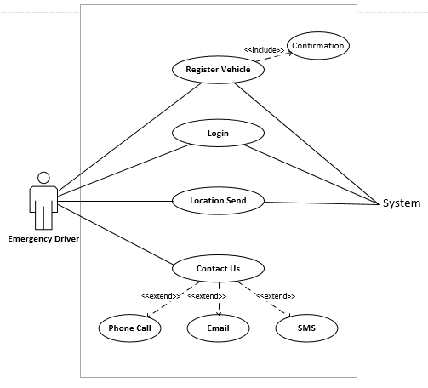

**Figure 3.1 Emergency vehicle Use Case**

#### **Use case ID: UC-3.1**

**Use-Case Name**: Register Vehicle

**Actor**: Emergency vehicle driver

**Description**: Emergency vehicle driver will register his vehicle.

**Pre-condition** Emergency vehicle driver should have to give accurate and relevant information where he want to register his vehicle.

**Post-condition**: Emergency vehicle driver successfully register his vehicle.

#### **Use case ID: UC-3.2**

**Use-Case Name**: Login

**Actor**: Emergency vehicle driver

**Description**: Emergency vehicle driver shall be able to login to the dashboard.

**Pre-condition**: Emergency vehicle driver insert his verify vehicle-no and password in order to login into our app.

**Post-condition**: Emergency vehicle driver shall be able to login to the dashboard easily.

#### **Use case ID: UC-3.3**

**Use-Case Name**: Location Send

**Actor**: Emergency vehicle driver

**Description**: Emergency vehicle driver shall be able send his vehicle current location.

**Pre-condition**: Emergency vehicle driver will perform the specific action that are require tosend his location.

**Post-condition**: Emergency vehicle driver successfully send his location.

#### **Use case ID: UC-3.4**

**Use-Case Name**: Contact Us

**Actor**: Emergency vehicle driver

**Description**: Emergency vehicle driver shall be able to contact us.

**Pre-condition**: Emergency vehicle driver will perform the specific action that are require to contact with us.

**Post-condition**: Emergency vehicle driver successfully contact us.

## **Functional Requirements**

Useful necessity is depicted in term that what a product can do, Functional requirement might be a type of count, expansion, refreshing and some other unequivocal capacity that characterize that what a framework should be achieve. In term of programming designing utilitarian prerequisite characterizes the framework capacities and its part. It determine the specific consequence of the framework. Nonfunctional prerequisite for the most part bolster utilitarian necessity which are otherwise called quality prerequisite forces it's imperative on the structure or usage. Useful necessity likewise rely upon the kind of programming, expected client and sort of framework where programming utilized.

### **Functional requirements of our system are:**

**Table 3.1 Functional Requirements**

|  |  |  |
| --- | --- | --- |
| **Requirement ID** | **Requirement Title** | **Requirement Description** |
| FR – 1 – 01 | Admin login | Admin must login to system in order to perform all the functionalities. |
| FR – 1 – 02 | Add records | Admin will add the records that will use the system. |
| FR – 1 – 03 | Update records | Admin can update the employee’s record. |
| FR – 1 – 04 | Delete records | Admin can delete the records of employees. |
| FR – 2 – 01 | Employee login | Employee can also login to the system to monitor the signal working. |
| FR – 2 – 02 | Switch signals working | Traffic controller can turn ON or OFF the traffic signals. |
| FR – 2 – 03 | Switch traffic  signal mode | Traffic controller can switch the signal mode. |
| FR – 2 – 04 | Fix time delay mode | Signal works on fixed time delay in this mode |
| FR – 2 – 05 | Density mode | Signal works according to density of vehicle. |
| FR – 2 – 06 | Monitor signal  working | Employer can monitor the flow of signals through webpage. |
| FR – 3 – 01 | IR Receiver | IR receiver tell our system regarding emergency location. |
| FR – 4 – 01 | IR remote | Give the priority to the Emergency vehicle side. |

## **Non Functional Requirements**

Non Functional requirements are those requirements which are especially characterize/expand the execution or normal for a framework. Nonfunctional necessity is a limitation that indicates a type of criteria that is utilized to assess the diverse activity of framework.

### **Non Functional Requirements of our system are**

**Table 3.2 Non Functional Requirements**

|  |  |  |
| --- | --- | --- |
| **Requirement ID** | **Requirement Title** | **Requirement Description** |
| NR – 1 – 01 | Performance | Our system should perform well without delaying any action. |
| NR – 1 – 02 | Usability | Our system is user friendly that everyone can use it with ease without facing any difficulty and user interface is simple and interactive. |
| NR – 1 – 03 | Security | Proposed system is highly secured because only valid person will get access and only authorized person will be able to login the system. |
| NR – 1 – 04 | Scalability | Our Proposed system must have the capability to perform well even when the size and volume of the system increase according to needs of the use. |
| NR – 1 – 05 | Extensible | System should have the ability to be able to update and add new features. |
| NR – 1 – 06 | Reliability | Integrate in such a way that it should not crash due to error of integration. |

Chapter 4

Design & Architecture

# **Design & Architecture**

## **Block Diagram**

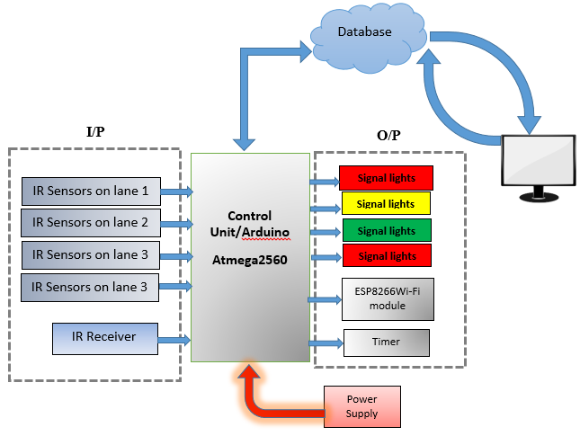

**Figure 4.1 Block Diagram**

## **Activity Diagram Description**

An activity diagram is similar to a flowchart, which illustrates the control of one activity to another. Activities can be arranged as a systematic approach. Control flow starts from a single activity and then breaks into further activities. This flow is progressive or simultaneous. The development outline performs extensive flow control by using error-free ordering sections similar to joins, junction, etc.

* Admin Activity Diagram
* Employee Activity Diagram
* Hardware Activity Diagram

### **Admin Activity Diagram**

Above activity diagram represents the data flow of admin activity that first of all admin must login into the system through valid CNIC and password after that admin will be able to register employees (that is traffic controller) also admin can view the status of current employee and can monitor the signals through screen.

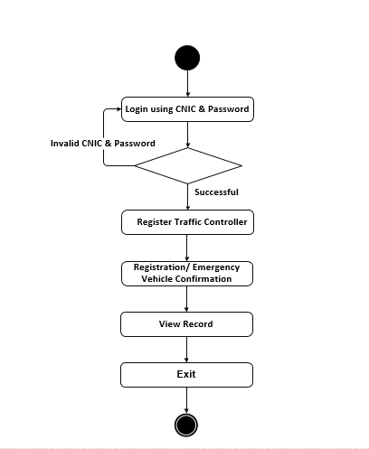

**Figure 4.2 Admin Activity Diagram**

### **Employee (Traffic Controller) Activity Diagram**

This activity diagram represents the data flow of employee activity that first of all user login into the system after that he will be able to start the signal, monitor the flow of signals, switch signal mode and also can stop the working of signals.

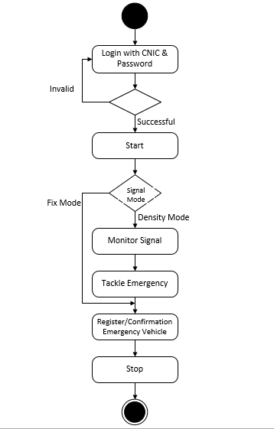

**Figure 4.2 Traffic Controller Activity Diagram**

### **Hardware Activity Diagram**

The above activity diagram show the activity of microcontroller, their sensors and how the process flow, when microcontroller will turn on, it will first check the emergency vehicle. If found, it give the priority to that side and in other case if no emergency vehicle there, it will check the density through sensor and a lot the time delay accordingly. Keep in mind that the flow of signal will never change either it’s a clockwise or anti-clockwise.



**Figure 4.2 Hardware Activity Diagram**

## **Sequence Diagram**

UML give different sorts of diagram to make an elucidation of structure need to system commitments gathering plot are used here to address the extraordinary endeavors of the whole system. The progression plot are common depiction of correspondence of articles. The convenience of use cases is delineated using game plan diagram. Progression graph is a contact layout that is demonstrate unmistakable things with the message send and gotten by those articles. Summary of Sequence layout that are seen in the system as the structures of the system might be.

* Admin Sequence Diagram
* Sequence Diagram for Traffic Control System

### **Sequence Diagram for Admin**

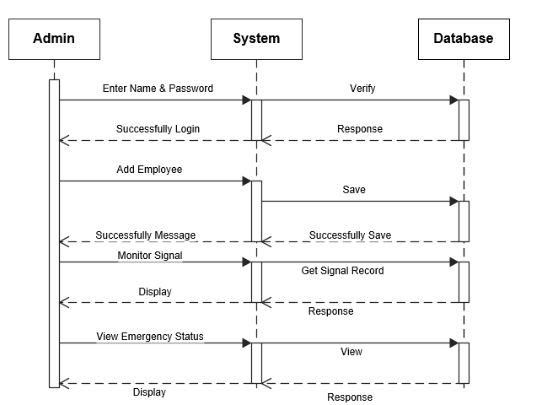

**Figure 4.2 Sequence Diagram for Admin**

#### **Description**

The sequence diagram that are shown in above depicts the sequence of data flows in admin panel, first of all admin login to the system by entering a valid CNIC and password if they enter the valid information then admin will be able to perform following activities like add record of employees, update, delete and also be able to monitor the signal and see the status of emergency vehicle.

### **Sequence Diagram for Traffic Control System**



**Figure 4.2 Sequence Diagram for Traffic Control System**

#### **Description**

The sequence diagram that are shown in above depicts the complete sequence of how the traffic controller interact with our system in order to monitor the traffic signals. Traffic controller start the signal working through webpage and with the help of Wi-Fi module webpage can send and receive command to atmega2560. Sensor that attach with atmega2560 give him an information about density and base on that information, atmega2560 set time delay for signal lights.

### **Sequence Diagram for Emergency Driver**

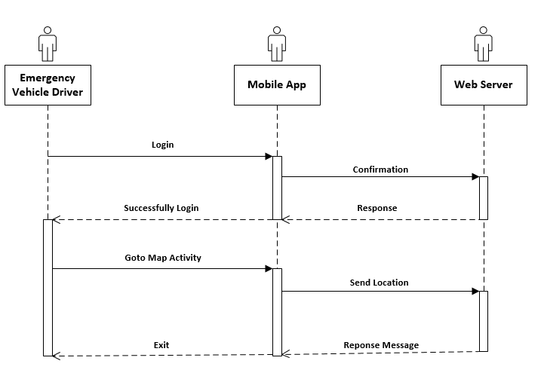

**Figure 4.2 Sequence Diagram for Emergency Driver**

#### **Description**

Above sequence diagram show the complete sequence of how the Emergency vehicle driver interact with our system in order to send his vehicle location.

## **Data Flow Diagram**

### **DFD Level 0**



**Figure 4.3 DFD Level 0**

#### **Description**

The system level 0 diagram show the flow of data in which the complete working of a system is shown that how external entities interact with our system.

### **DFD Level 1**



**Figure 4.4 DFD Level 1**

#### **Description**

The system level 0 diagram show the flow of data in which the complete working of a system is shown that how external entities interact with our system.

## **Entity Relationship Diagram ERD**



**Figure 4.4 ERD Diagram for System**

### **Description**

Above activity diagram show the entity relationship of admin traffic signal and signals. Admin has a one to many relationship with Traffic controller. Its mean Admin can add, update and view multi traffic controller employee record. Admin and Traffic controller both can view the signals record.

Chapter 5

Implementation

# **Implementation**

This chapter is the main focus of each project, where we will discuss the development stage of our project, how we configure the system and integrate it with our software by using various type of technologies. It is much equivalent to making your dreams certified. This phase help us a lot in learning and building our technical skills. We become familiar with multiple technologies and polish our software building capability and technical skills. Our decision become on execution stage.

## **Algorithm**

The sequential step t of our system work are as following.

1. Get start with initializing all the input and output port
2. Read the Sensor input.
3. While ( all sensor value==0)
   1. Turn the yellow LED ON and OFF.
4. For ( I = 1, I <= 4, I++):

Check Emergency

* 1. If (emergency occur at any road)
     1. Allot time to that side.
  2. Else
     1. Go to step 5

1. Check road density
   1. If (density==low)
      1. Turn ON signal (green) for 6 seconds.
   2. Else If (density==medium)
      1. Turn ON signal (green) for 9 seconds.
   3. Else If (density==high)
      1. Turn ON signal (green) for 12 seconds.
   4. Else
      1. Go to Step 4 for emergency and then check the next road density in cycle.
2. Go to Step 3
3. End

## **External API**

External API’s are use in various project to configure our system with some external environment. They give us an ease in our project.

### **Google Map API**

We used the Google Map API in our system to tackle the Emergency Vehicle Problem. By using this API, we can easily acquire the current location of Emergency and on basis of this, we can change the traffic signals.

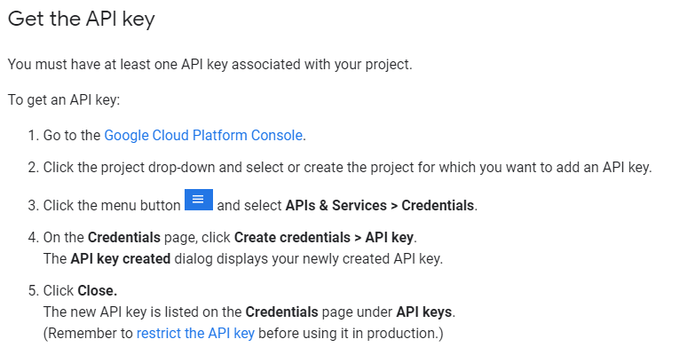

**Figure 5.1 Google Map API**

**Table 5.1 External APIs**

|  |  |  |  |
| --- | --- | --- | --- |
| Name of API | Description of API | Purpose of usage | List down the function/class name in which it is used |
| Maps JavaScript API | Google Map API is use to implement Google map in our website | To view the emergency vehicle location. So, provide them a good route. | initMap() in Map Page. |

## **User Interface**

User interfaces is the major concern of each activity or a project that provides the bridge between user and machine. It should be an interactive, user-friendly and convenient to use. In this step, all of the screen shot of project interface will be paste here.

### **Website**

#### **Login Page**

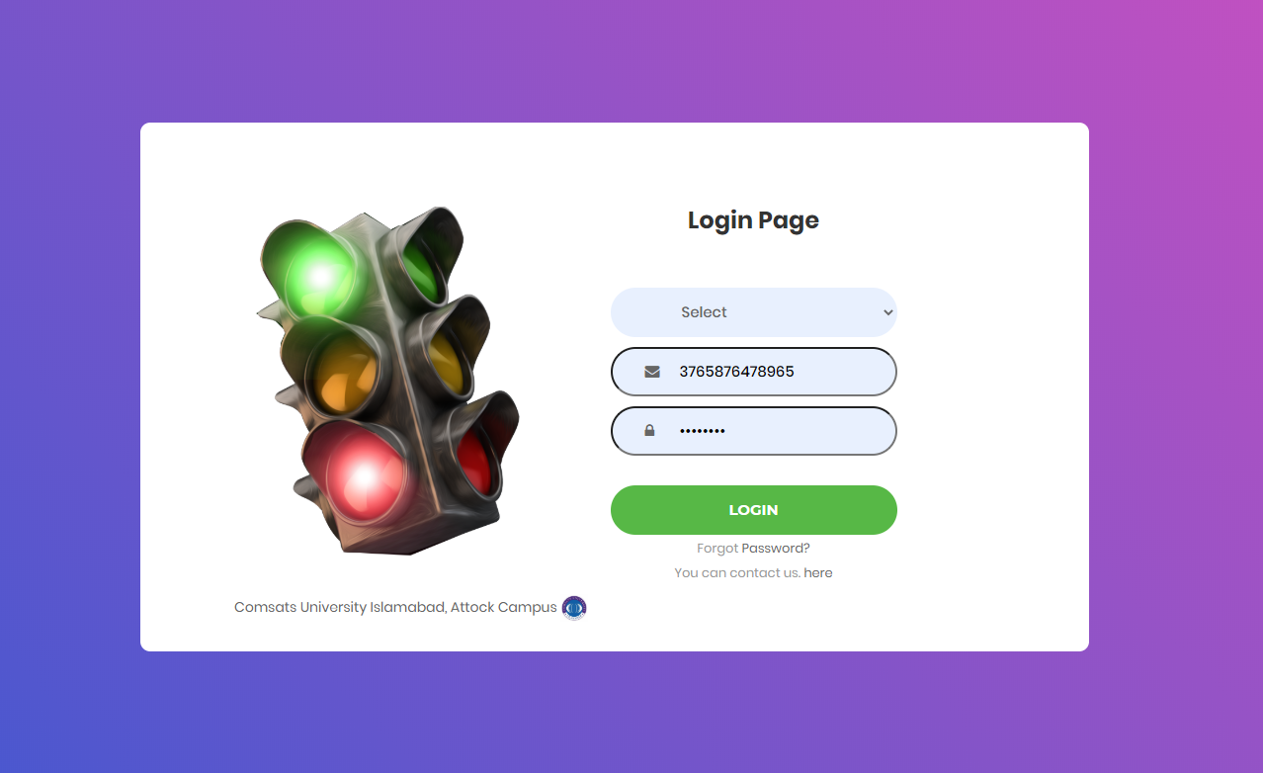

**Figure 5.2 Website login**

**Description**

This is the login page of Density Base Traffic Signal Control Room through which admin and traffic controller will be logged in.

#### **Webpage for Admin**

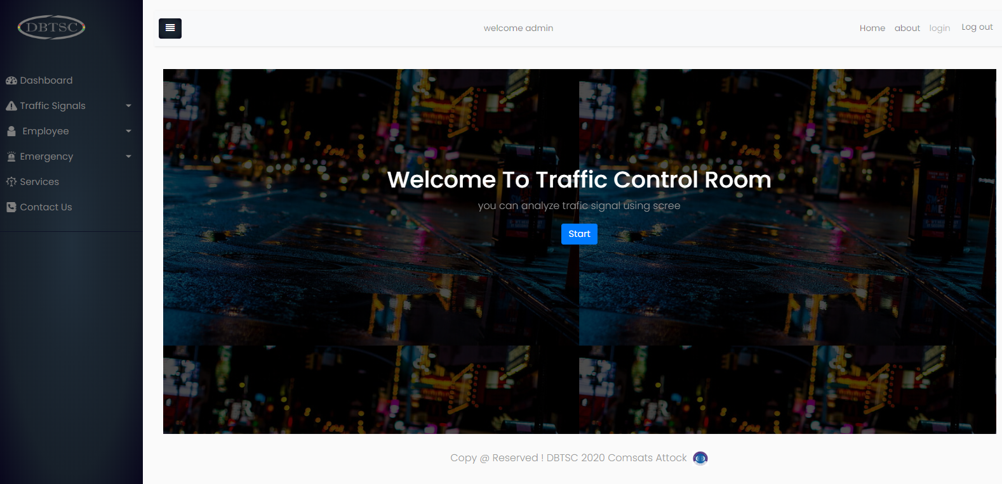

**Figure 5.3 Admin Dashboard**

**Description**

This is the Home page for admin where he/she can perform all activities mentioned above.

#### **Webpage for Monitoring Room**

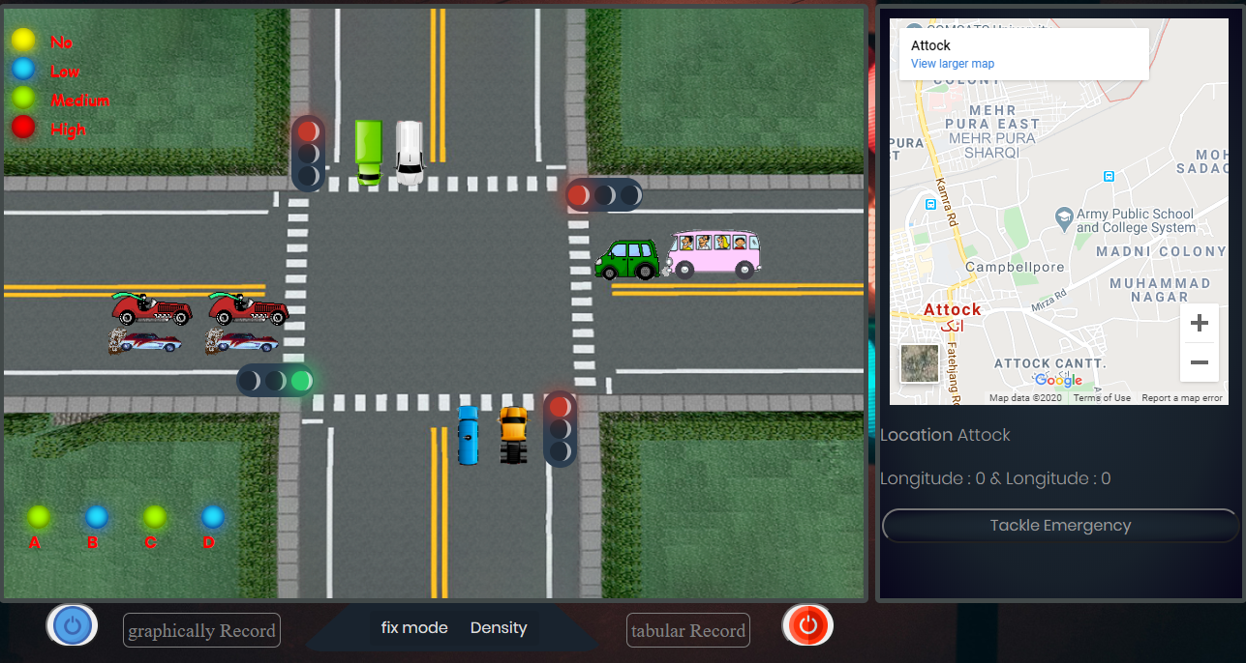

**Figure 5.4 Monitoring Room Graphically Representation**

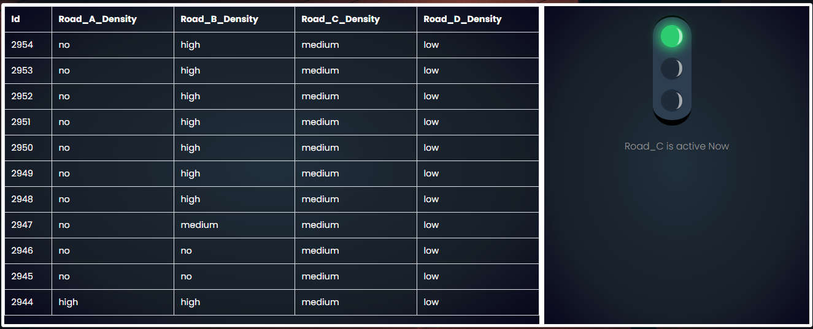

**Figure 5.5 Monitoring Room Tabular Representation**

**Description**

These are the webpage for monitoring room, through this admin or traffic controller will monitor the traffic light signal flow, and can change the various mode of signals.

#### **Traffic Controller Registration**

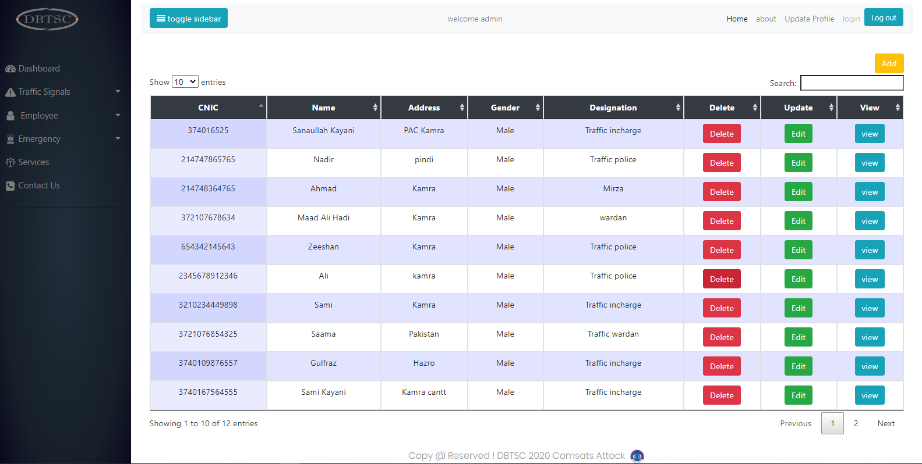

**Figure 5.6 Traffic controller’s record**

**Description**

This is the web page to register traffic controller and view, update or delete their record.

#### **Registered Employee**

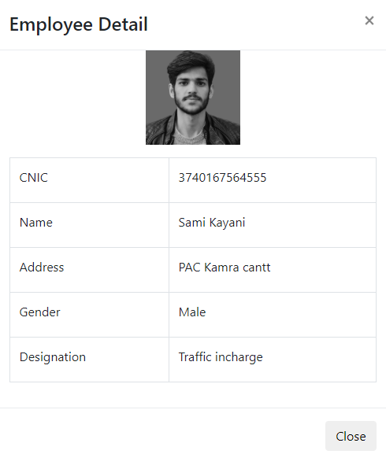

**Figure 5.7 Registered employee**

**Description**

Admin can also view the record of registered traffic controller.

#### **Web Page Emergency Vehicle**

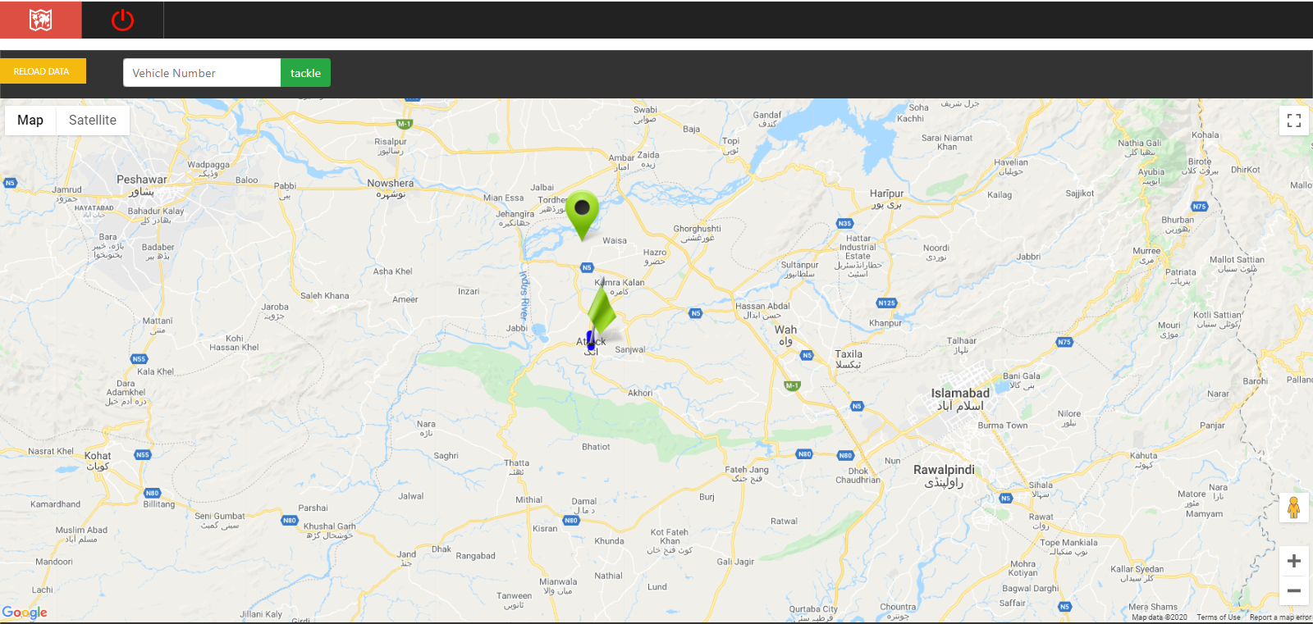

**Figure 5.7 Emergency Map**

**Description**

This activity will show the record of Emergency Vehicle on Map.

### **Android**

#### **Login Page**

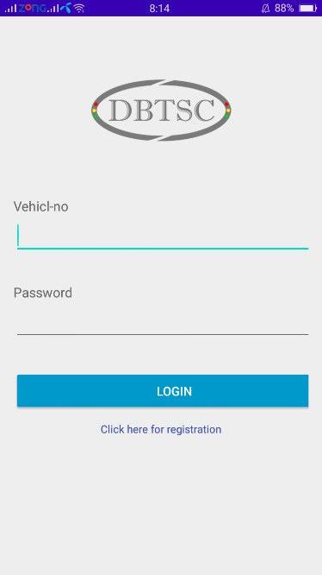

**Figure 5.8 Emergency Login**

**Description**

This is a login activity for Emergency Vehicle drive.

#### **Emergency Vehicle Registration**

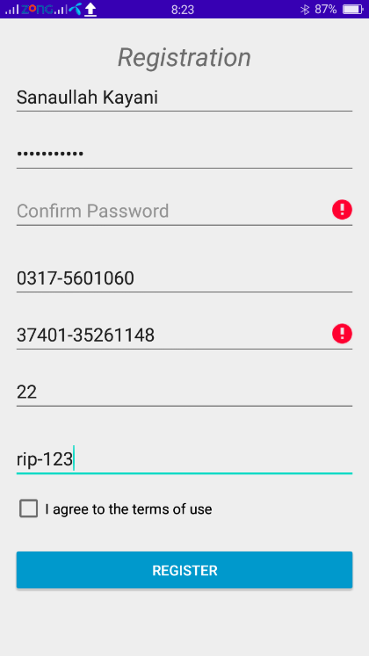

**Figure 5.9 Emergency Registration**

**Description**

Emergency vehicle driver send registration request of his/her vehicle from this activity.

#### **Dashboard**

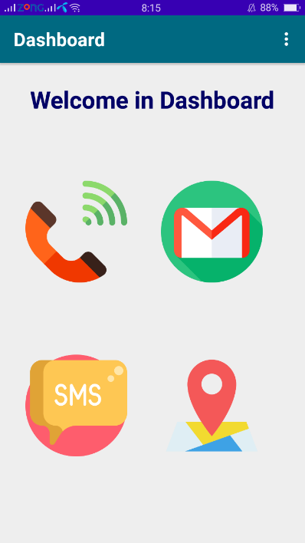

**Figure 5.10 Emergency dashboard**

**Description**

This is the main page of app.

#### **Emergency Location Send**

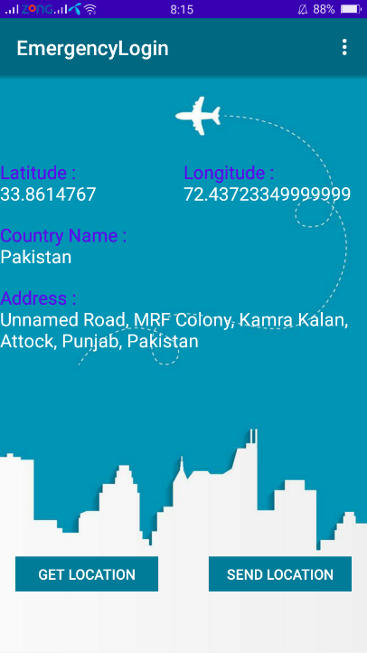

**Figure 5.11 Emergency Location**

**Description**

Emergency driver will send his location from this activity. The record will automatically show on the screen when he became in this activity, otherwise he must have to click get location.

### **Configuration of Arduino & Wi-Fi**

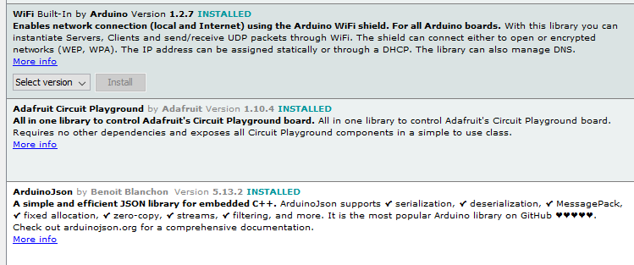

**Figure 5.12 Configuration of Arduino and Wi-Fi**

### **System Integration**

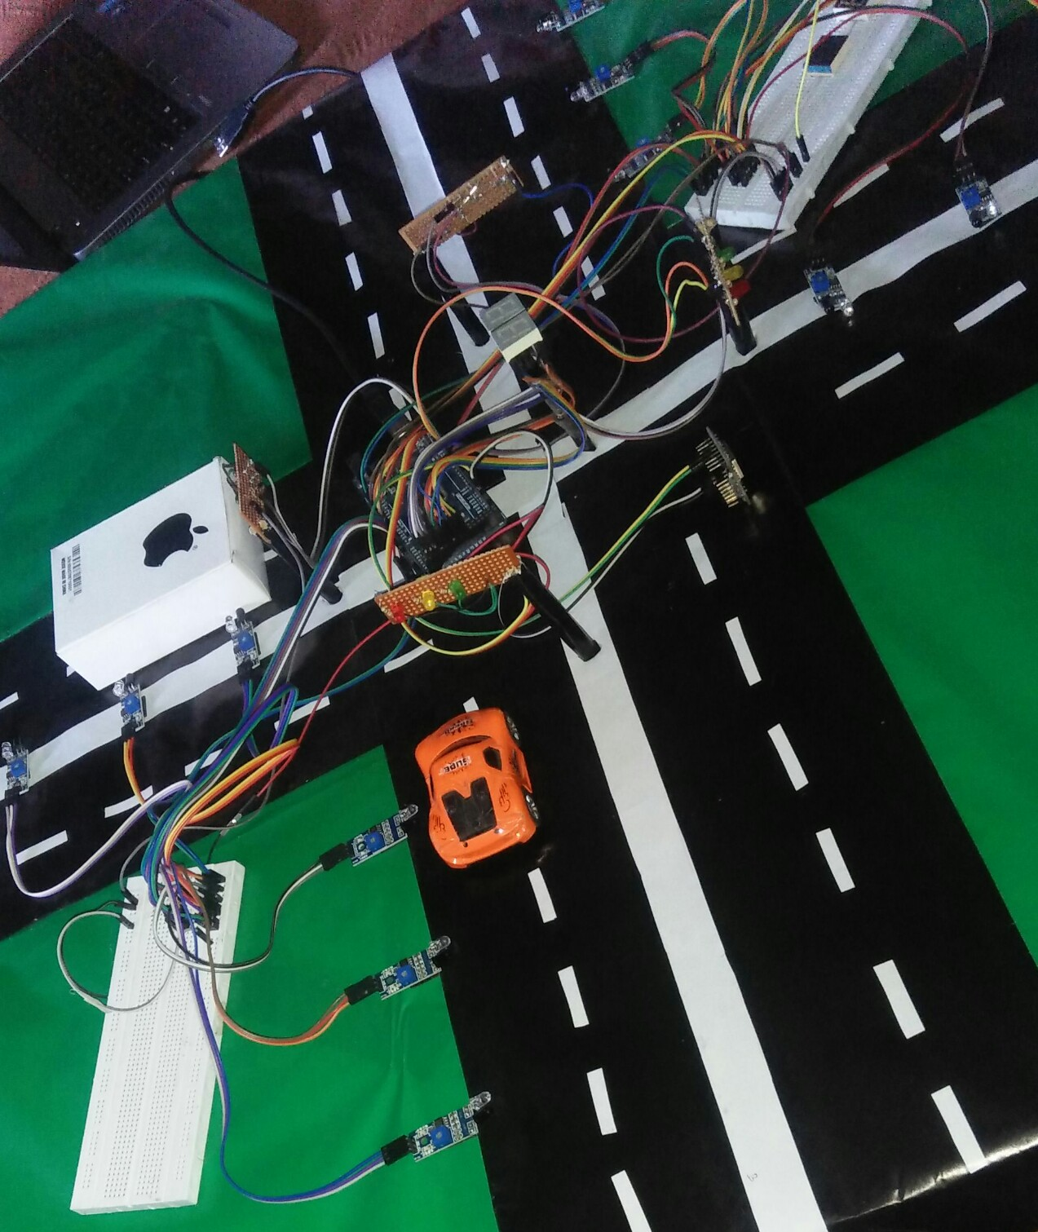

**Figure 5.13 System Integration**

Chapter 6

Test & Evaluation

# **Testing & Evaluation**

Testing Phase is the major concern while you are evaluating the project. In this phase, all of the functional requirement are being testing to check whether the system works properly as per our requirement and meet the major goal. Individually, each and every component if they are working perfectly according to our given criteria and remove all the bugs that come occur while testing. Evaluation and testing of functional are describe below.

## **Manual Testing**

### **System Testing**

System test cover the overall working of project, where the entire system works dreamily or not.

### **Unit Testing**

Unit testing is the phase of testing, where we test every little piece of our product code and check invalid an incentive in various content field, invalid IR sensor, Wi-Fi, Receiver and furthermore test legitimate information. Every bit of code is confined and working properly.

Every function is test separately and become it a bug free by debugging. Code debugger helps us a lot in this phase to handle multiple exceptions and remove all the bugs that’s come occur in coding and fix them.

### **Functional Testing**

Functional testing include the testing of all the functions. In this phase, Functions are tested by give some dummy input and evaluate its output by comparing it with the required result in form of the test case.

#### **Test case for admin**

|  |  |  |  |  |  |
| --- | --- | --- | --- | --- | --- |
| **No.** | **Test Case** | **Input** | **Actual Output** | **Expected Output** | **Pass/Fail** |
| 1. | Enter valid CNIC & password | Email CNIC & password | As Expected | Access Guaranteed | Pass |
| 2. | Enter Invalid CNIC & password | Email CNIC & password | As Expected | “An error message occur” | Pass |
| 3. | Password field empty | Empty | As Expected | Show alert message “Password is required” | Pass |
| 4. | Register Traffic Controller | Insert Record | As Expected | Record Added | Pass |
| 5. | Register Traffic Controller | Invalid Record | As Expected | Record not inserted, and alert message occur with error. | Pass |
| 6. | Register Emergency | Valid Employee Info | As Expected | Record Added | Pass |
| 7. | Register Emergency | Invalid Employee Info | As Expected | Record not Added, and alert message occur with error. | Pass |
| 8. | Confirmation Emergency | Click on Verify button | As Expected | Vehicle verified. | Pass |

#### **Test case for Traffic controller**

|  |  |  |  |  |  |
| --- | --- | --- | --- | --- | --- |
| **No.** | **Test Case** | **Input** | **Actual Output** | **Expected Output** | **Pass/Fail** |
| 1. | Enter valid CNIC & password | Email CNIC & password | As Expected | Access Guaranteed | Pass |
| 2. | Enter Invalid CNIC & password | Email CNIC & password | As Expected | “An error message occur” | Pass |
| 3. | Password field empty | Empty | As Expected | alert occurs “Password is required” | Pass |
| 4. | Update Profile | Valid Info | As Expected | Record Updated | Pass |
| 5. | Forget password | Valid information | As Expected | Password Forgot | Pass |
| 6. | Forget password | Invalid information | As Expected | Alert “your answer is wrong” | Pass |

### **Integrated Testing**

In this stage, we blend at least two modules to check working of our product. For instance, checking correspondence among hardware and software and assess the outcomes.

#### **Integrated Test no 1**

|  |  |  |  |  |
| --- | --- | --- | --- | --- |
| **Test No** | **Test Condition** | **Expected Result** | **Actual Output** | **Status** |
| Test 1 | Traffic Controller Switch Signal to ON state. | Traffic Signal will ON. | Traffic Signal become ON. | Pass |
| Test 2 | Traffic Controller give command to Switch Signal ON. | Traffic Signal will OFF. | Traffic Signal become OFF. | Pass |
| Test 3 | Traffic Controller  Change mode to Fix. | Signal Works As Fix mode. | Signal starts working on Fix mode. | Pass |
| Test 4 | Traffic Controller  Change mode to Density. | Signal Works As Density mode. | Signal starts working on Density mode. | Pass |

#### **Integrated Test no 2**

|  |  |  |  |  |
| --- | --- | --- | --- | --- |
| **Test No** | **Test Condition** | **Expected Result** | **Actual Output** | **Status** |
| Test 1 | Wi-Fi module is off and send data to Arduino | Arduino doesn’t pass the data to phpMyAdmin database | Arduino doesn’t pass the data to phpMyAdmin | Pass |
| Test 2 | Arduino is connected to Wi-Fi and check that it sends data to phpMyAdmin | Arduino send data to phpMyAdmin  database | Arduino send data to phpMyAdmin  database | Pass |
| Test 3 | Arduino send data regarding road density to website. | Road density will display on Website. | Road density displays on Website | Pass |

#### **Integrated Test no 3**

|  |  |  |  |  |
| --- | --- | --- | --- | --- |
| **Test No** | **Test Condition** | **Expected Result** | **Actual Output** | **Status** |
| Test 1 | Emergency driver send registration request to web server. | Request should be send to web server. | Request successfully send. | Pass |
| Test 2 | Emergency driver send location to web server. | Emergency location should be send to web server. | Emergency location successfully send | Pass |

## **Automated Testing**

### **Automated testing tool**

|  |  |  |  |
| --- | --- | --- | --- |
| **Tool Name** | **Tool Description** | **Test description** | **Results** |
| Jenkins | It is an open source automated testing tool with a lot of plugins that we can use to test software’s. | We use this tool for testing the User Interface of Website and android application. | Pass |
| Chrome DevTools | It’s a web developer tool. | We use this tool for finding the Website bugs. | Pass  (No error found) |

CHAPTER 7

Conclusions & Future Work

# **Conclusion and Future Work**

## **Conclusion**

The introduced framework contain Microcontroller that effectively get the data from IR sensor and send it to the Website our ESP8266 Wi-Fi. Density Base Traffic Signal Controller allot a time to the signal according to their road density irrespective of fix time delay, that helps to reduce the conjunction at intercept point and provide the ease to the Traffic employers. Traffic controller easily monitor the signal record and trigger the signal mode from density to fix or vice versa. This system also provide a best path to the emergency vehicle that is very difficult to tackle in current signal mode. The Density system innovation can be utilized as real environment scenario by using a relay and high range sensor.

## **Future Work**

In future IN SHA ALLAH we have decided to make this project on image processing technique and apply certain machine learning so that it would be more reliable and worth able.

# **References**

<https://ieeexplore.ieee.org/document/8365387>

<https://ieeexplore.ieee.org/document/8597392>

<https://www.researchgate.net/publication/324537810_An_Iot_Based_Traffic_Signal_Monitoring_and_Controlling_System_Using_Density_Measure_of_V>

<https://nevonprojects.com/iot-traffic-signal-monitoring-controller-system/>